# How to run App

To run the app, you need to have installed:

* Android studio
* Python
* Pyperclip library

To install the app open android studio and open the folder named android in the repository with the IDE. Then on your phone enable developer options by finding and tapping your android build number in the settings 8 times. After this step enable USB debugging from the developer options on your phone then plug it in the computer and allow the computer access from your phone. Then press the run icon in the top right of the IDE when the name of your phone appears.

After this run the python script terminalCopy on your PC using python 2.7

# Creation of App

When creating the project pick empty activity

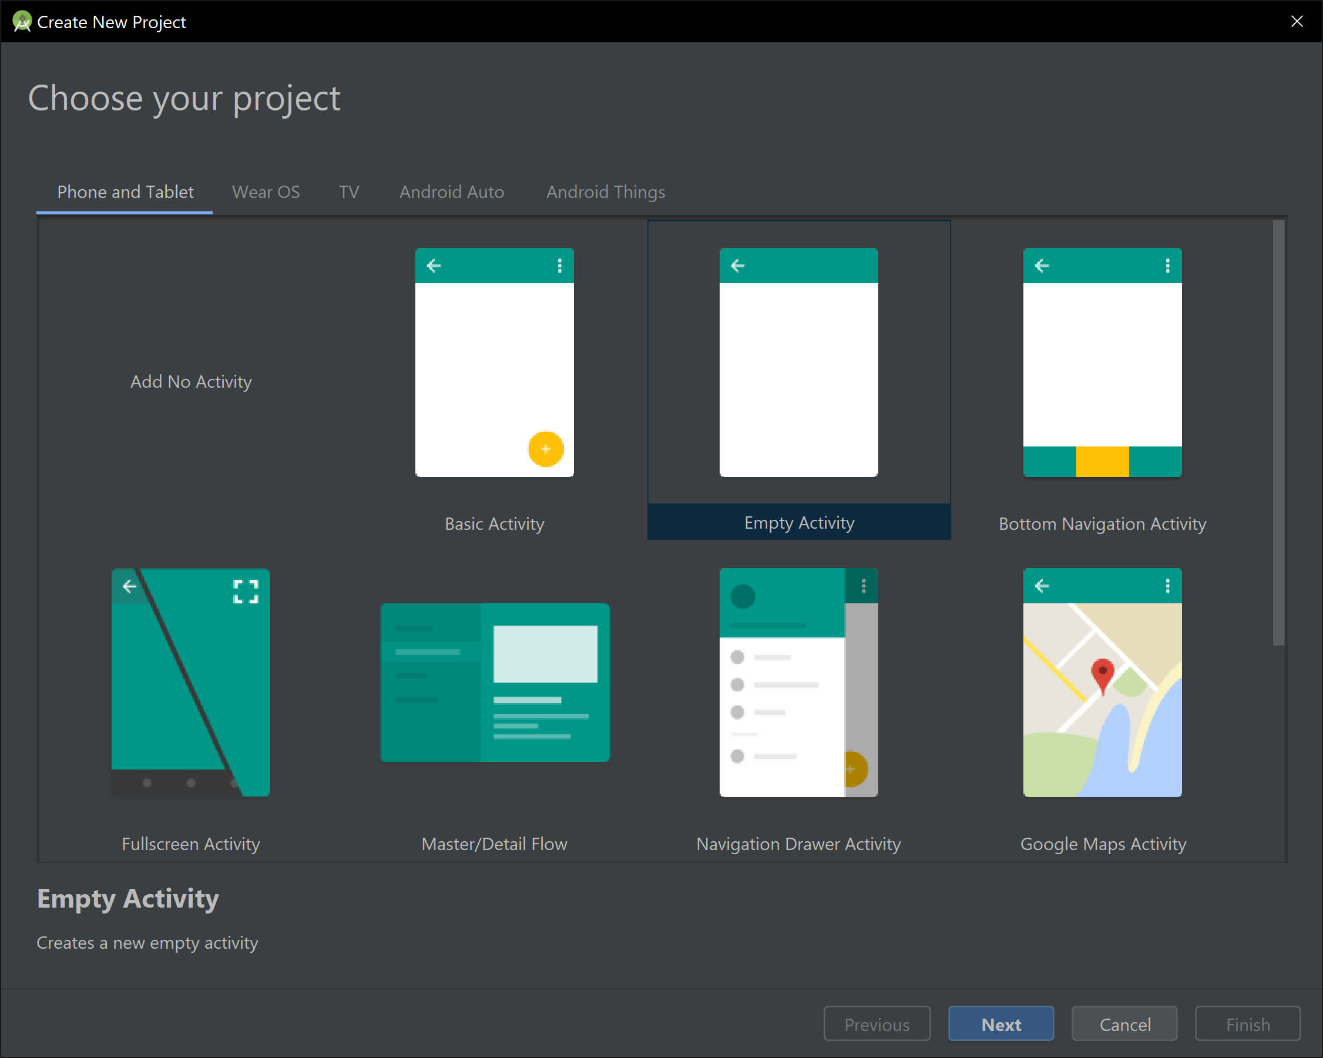

Once the app Is named android studio will make the project.

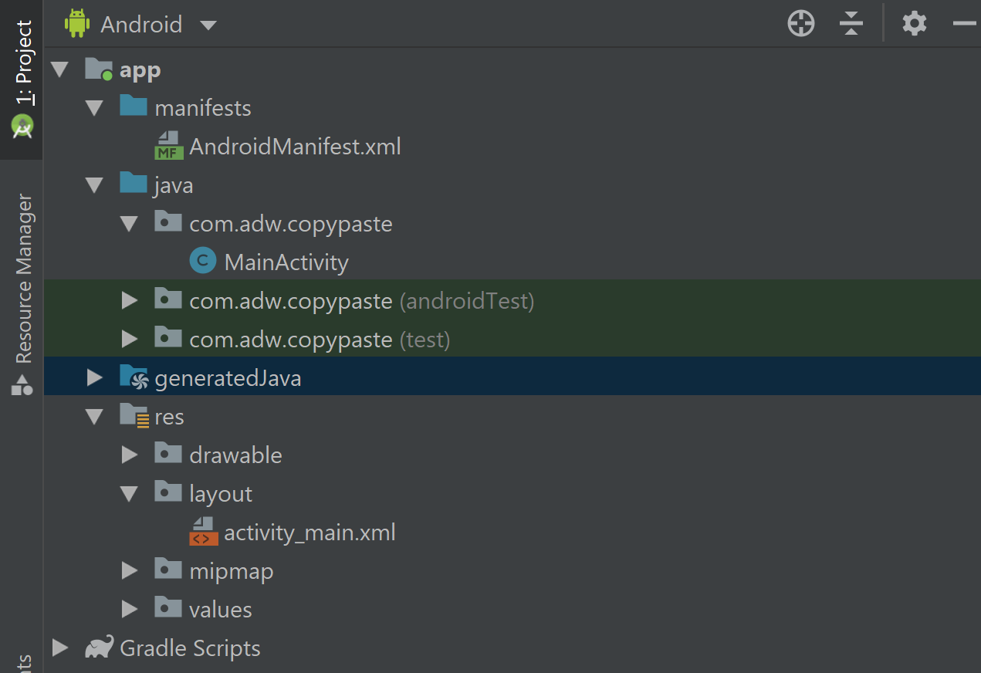

These files are made by android studio and the most important ones are:

AndroidManifest.xml – This file is the file that describes the fundamental characteristics of the app and defines the components such as which activity is the home page.

MainActivity – This is the initial activity and will contain a hello world application by default

res – This hold the data for the visual design of the app such as the layout and colours

The strings.xml file holds all the text for the application such as button names and labels

The activity_main.xml is used to hold the code for what is displayed on the screen. The view is a drag and drop GUI to add elements to the screen however it can be changed to the text view by using the button at the bottom of the editing screen. The code for the display is done in the xml language.

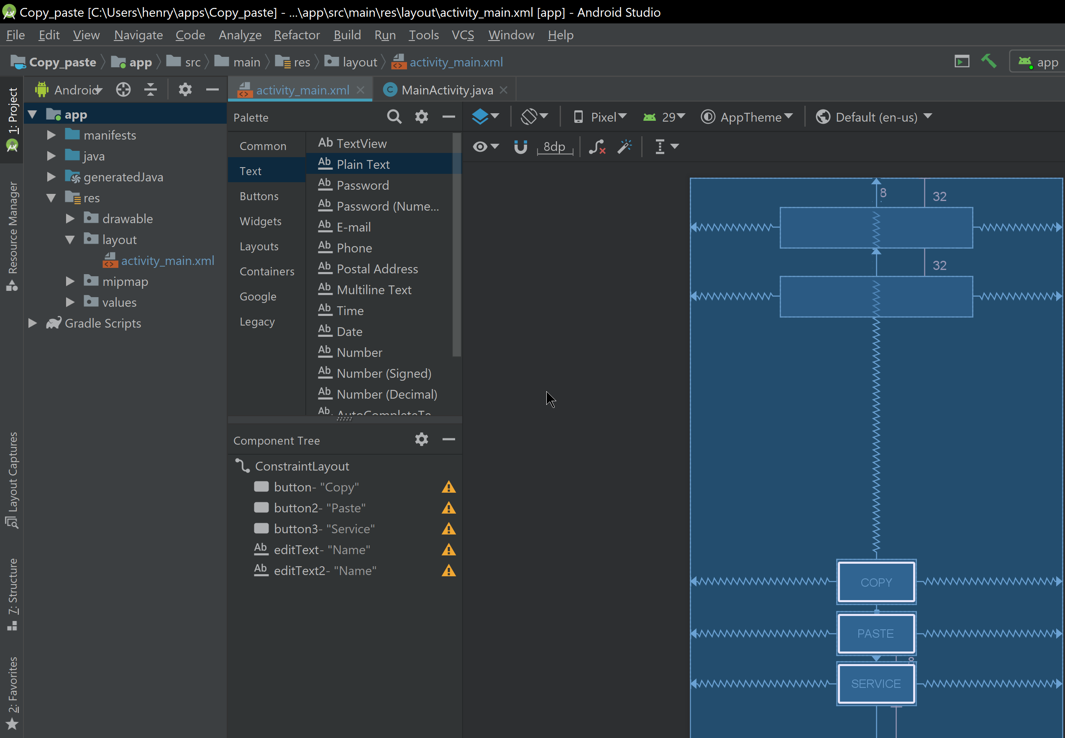

In the text view you can change the properties of the on-screen elements

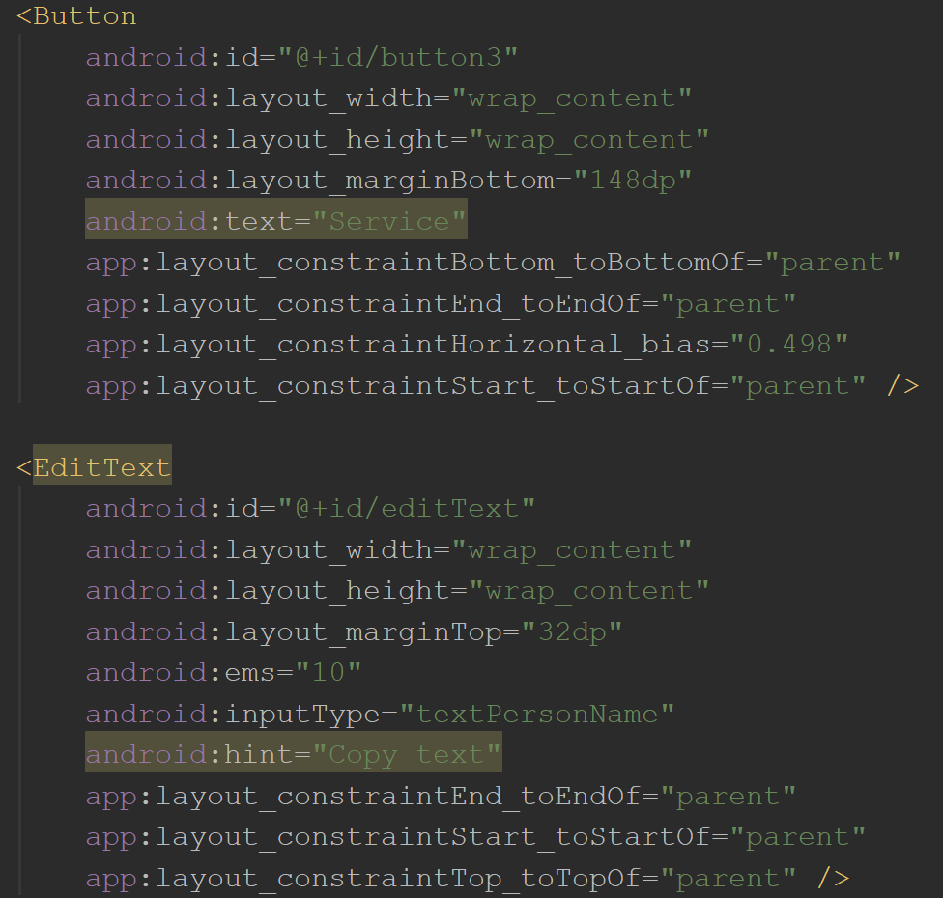

Each class goes within its own file

# Creation of desktop App

INstalll python libs:

